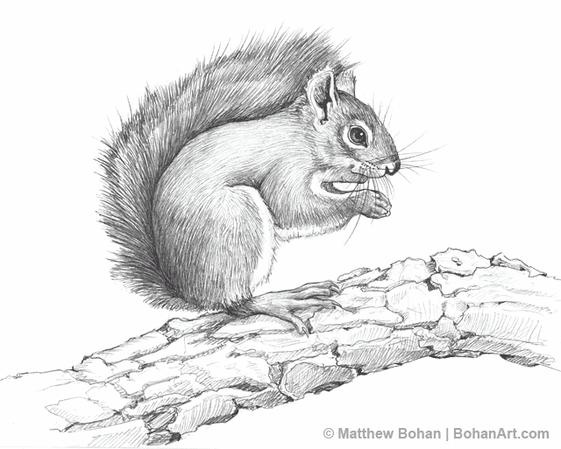**LPZ Fecal Hormone Extraction Protocol—Shaking**

**Mount Graham’s Red Squirrel**

**Updated: 10/10/19 KJF**

1. Weigh out **0.0500 grams ± 0.0020g wet feces (0.0480-0.0520g)** that has been well mixed into pre-labeled 12x75 mm plastic tubes. Avoid plant and other debris. Try to put all of the feces as the bottom of the tube. (Don’t forget to tare the scale with the plastic tube…not all tubes weigh the same.)
2. Record the exact weight of each sample.
3. Add 0.45 ml of ethanol (100%) and 0.05mL of distilled water (or 0.5mL of 90% EtOH) to each tube and vortex very briefly.
4. Cap and shake tubes on Glas-col mixer (on setting 60) for 30 minutes.
5. Centrifuge tubes (make sure the centrifuge is balanced) at 1500 rpm for 20 minutes.
6. Pour off extracts into a second set of labeled 12x75 mm tubes. Be sure to get all of the ethanol (or as much as possible and be consistent).
7. Add 0.45 mL of ethanol and 0.5 mL of distilled water (or 0.5mL of 90% EtOH) to the original tubes containing the fecal pellets and vortex each tube for 30 seconds.
8. Centrifuge these tubes at 1500 rpm for 15 minutes.
9. Pour off the extract into the second set of tubes containing the first extract.
10. Dry down the extract under air in a warm water bath (avoid contaminating the blower prongs with your samples). Throw away the first set of tubes containing the fecal pellet and its caps.
11. Add 2 to 3 glass beads to each tube. Reconstitute dried extract in 0.5mL of dilution buffer. Vortex briefly. These are now at 1:5.
12. Cap and sonicate the samples for 20 minutes.